Project Design Phase-II Technology Stack (Architecture & Stack)

|  |  |
| --- | --- |
| Date | 15 October 2022 |
| Team ID | PNT2022TMID37038 |
| Project Name | Project - A Gesture-based Tool for Sterile Browsing of Radiology Images |
| Maximum Marks | 4 Marks |

# Technical Architecture:

The Deliverable shall include the architectural diagram as below and the information as per the table1 & table 2

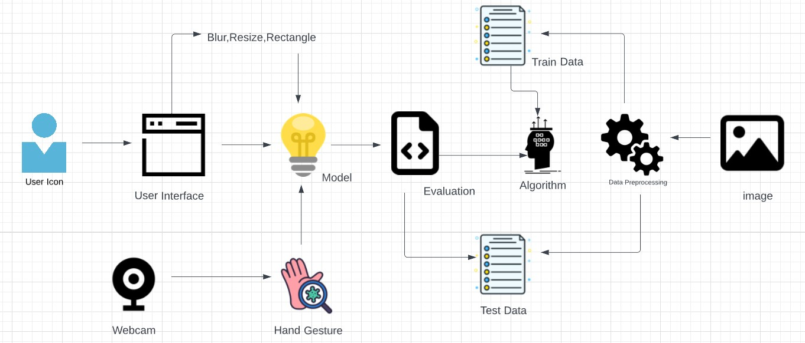

# Table-1: Components & Technologies:

|  |  |  |  |
| --- | --- | --- | --- |
| **S.No** | **Component** | **Description** | **Technology** |
| 1. | User Interface | Web UI Application | HTML, CSS, JavaScript |
| 2. | Dataset | Collect or create the hand gesture dataset | Hand Gesture Images |
| 3. | Data pre-processing | Import the library files | Python |
| 4. | Model building | Build the CNN model | Python-IBM Watson Studio |
| 5. | Application building | Create HTML file | HTML, CSS, JavaScript |
| 6. | File storage | Store the code files and datasets | Local Filesystem |
| 7. | Deep learning | Used to analyse visual imagery, image processing, video capture | CNN, OpenCV |

**Table-2: Application Characteristics:**

|  |  |  |  |
| --- | --- | --- | --- |
| **S.No** | **Characteristics** | **Description** | **Technology** |
| 1. | Open-Source Frameworks | Application development, data pre-processing. | Visual studio code, anaconda navigator |
| 2. | Security Implementations | It identifies the gesture only when the hand is in front of the camera. | OpenCV |
| 3. | Scalable Architecture | It can be used in any environment and is able to identify the gesture | OpenCV |
| 4. | Availability | It is used to reduce the possibility of spreading infections | AI |
| 5. | Performance | Rapid response to the gesture. | CNN |